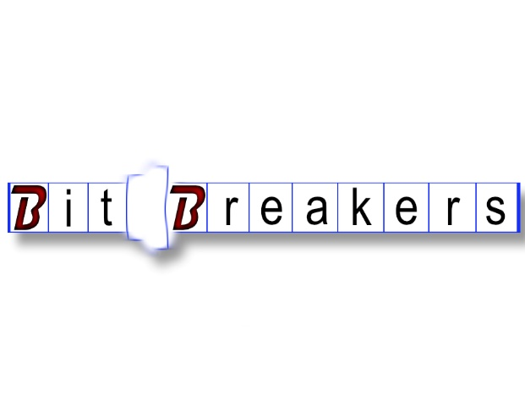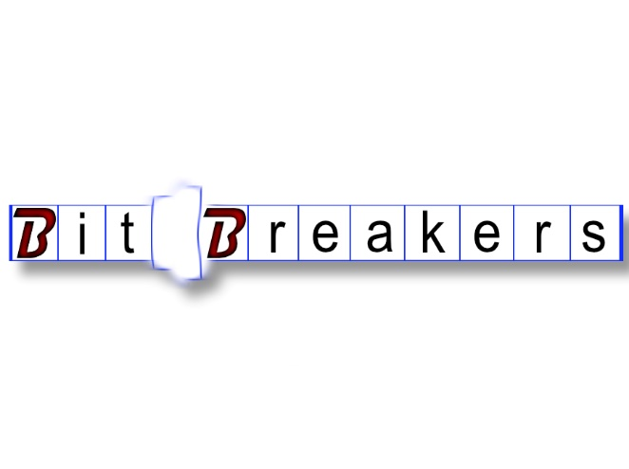

|  |  |
| --- | --- |
| Mike dietrich  123 Main, Salem, Or 97303  555-555-55555 | CEO  CS460.git  M@wou.edu | Mike dietrich  123 Main, Salem, Or 97303  555-555-55555 | CEO  CS460.git  M@wou.edu |
| Mike dietrich  123 Main, Salem, Or 97303  555-555-55555 | CEO  CS460.git  M@wou.edu | Mike dietrich  123 Main, Salem, Or 97303  555-555-55555 | CEO  CS460.git  M@wou.edu |
| Mike dietrich  123 Main, Salem, Or 97303  555-555-55555 | CEO  CS460.git  M@wou.edu | Mike dietrich  123 Main, Salem, Or 97303  555-555-55555 | CEO  CS460.git  M@wou.edu |
| Mike dietrich  123 Main, Salem, Or 97303  555-555-55555 | CEO  CS460.git  M@wou.edu | Mike dietrich  123 Main, Salem, Or 97303  555-555-55555 | CEO  CS460.git  M@wou.edu |
| Mike dietrich  123 Main, Salem, Or 97303  555-555-55555 | CEO  CS460.git  M@wou.edu | Mike dietrich  123 Main, Salem, Or 97303  555-555-55555 | CEO  CS460.git  M@wou.edu |